Deborah Barndt
DMD 113: History of Graphic Design
Nancy Sheeber
Journal Container Proposal
11-18-13

1. Name: L. Prang and Company and others

2. Date: c. 1880-early 1900s

3. Chapter 9: Graphic Design and the Industrial Revolution, Figure # 9-55

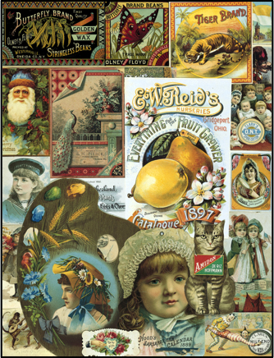
4.

5. I chose this image as my inspiration, because I always had a fascination with the retro/vintage advertisements or antiques since I was a kid. The fun artistic qualities of those images like the colors, fonts, and overall whimsical feel always seems to make me smile and reminds me of different memories from my life. That time period was all about family, togetherness, and the growth of entertainment. They also help me to recall stories that I would hear as a child just sitting there listening in amazement. It symbolizes the past and how I learned from it. I cherish every story that I was told to me by my relatives; because even though it's about their journey, it's about mine as well. I grew up going to museums, knowledge was very important, and was encouraged to learn more about my history. We learn from each other, and pass it down to future generations.

6. I want to influence and inspire others with this container design by showing them that the past is another part of their journey. We travel throughout history building our family's heritage, but some people take that for granted when it's a part of who you are. Everyone's journey is different, and I hope to influence others to realize that too. It's something to be cherished and passed down through many generations. If you think about it what may be current now, can be retro or vintage later on in life. Retro art is about stories and memories. It helps us to remember where we all came from, what we did as a child, and learning more about our family. Listen to the stories being told by your ancestors, because it's part of who you are. Though their journey may have ended, we continue it for them by adding another chapter to their story and filling up that suitcase one more time.

